Salon Appointment System

A Major ProjectSynopsis Submitted to



Rajiv Gandhi Proudyogiki Vishwavidyalaya, Bhopal
Towards Partial Fulfillment for the Award of

Bachelor of Technology
(Computer Science and Engineering)

Submitted By
Name 1(enroll. No)-0827CS211153
Name 2(enroll. No)-0827CS211155
Name 3(enroll. No)- 0827CS211194
Name 4(enroll. No)- 0827CS211197

Under the Supervision of
Prof. Ritika Bhatt



Department of Computer Science and Engineering
Acropolis Institute of Technology & Research, Indore
Jan-June2025

Introduction of the Project
The Salon Appointment System is a web-based application designed to streamline the appointment booking process for salons and their clients. Currently, many salons rely on manual methods like phone calls or physical appointment books, leading to inefficiencies such as double bookings, missed appointments, and difficulties in managing staff schedules. This project aims to address these issues by providing a centralized platform for clients to easily book appointments online, while enabling salon staff to manage bookings, client information, and staff schedules effectively. This system will improve operational efficiency, enhance customer experience, and increase overall business productivity.

Objective
The primary objective of this project is to develop a user-friendly and efficient online salon appointment system. This includes enabling clients to view available time slots, book appointments, receive confirmations, and manage their bookings. For salon staff, the system will provide tools to manage appointments, client profiles, staff schedules, services offered, and generate reports. The goal is to create a system that simplifies appointment management, reduces administrative overhead, and improves customer satisfaction.

Scope
This project will focus on developing a web-based application with features for appointment booking, client management, staff scheduling, and reporting. It will cover the design and implementation of the user interface, database, and backend logic. The initial scope will include basic appointment scheduling functionalities, but future enhancements could include features like online payments, loyalty programs, and integration with social media platforms. The project will not include hardware setup or integration with existing salon POS systems in this phase.

Study of Existing System

Existing System/Application | Problems Addressed | Advantages | Disadvantages | Gaps Identified
Bookeo | Online booking, scheduling | User-friendly interface, mobile app | Can be expensive for small businesses | Limited customization options
Square Appointments | Payment processing, scheduling | Integrated payments, easy setup | Limited reporting features | Lack of advanced scheduling options
Timely | Client management, scheduling | Comprehensive features, reporting | Can be complex to learn | Less intuitive UI compared to simpler apps
Acuity Scheduling | Automated scheduling, payments | Highly customizable, integrations | Can be overwhelming for basic needs | Price point might be high for smaller salons
Fresha | Free plan available, basic scheduling | Free option, easy to use | Limited features compared to paid options | May not be suitable for larger salons with complex needs

Project Description
The Salon Appointment System will be a web-based application. Clients can browse services, view staff availability, and book appointments through the user interface. Salon staff will access a separate dashboard to manage appointments, client data, and staff schedules. The system will use a database to store information about clients, staff, appointments, and services. The flow of information will involve client requests for appointments, which are processed by the system, checked against staff availability, and confirmed or rejected. Confirmed appointments are then stored in the database and reflected in the staff schedule.

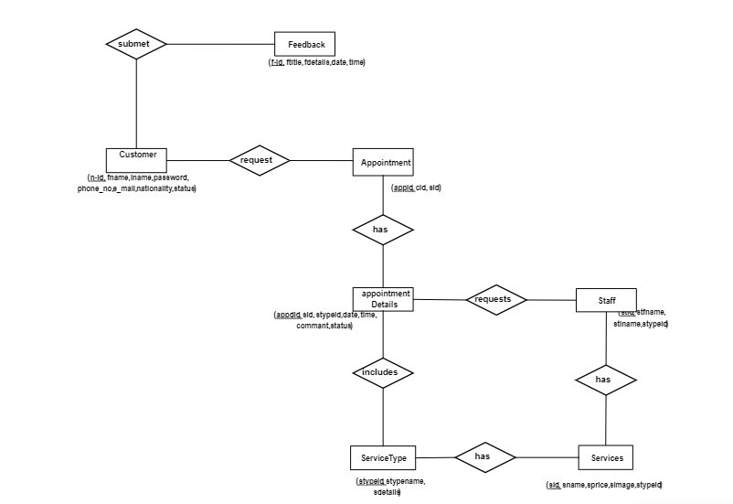
ER Diagram

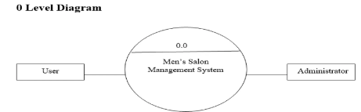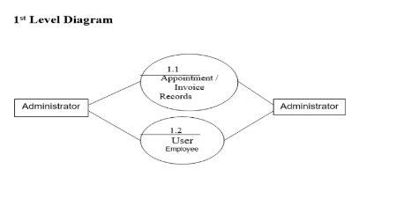

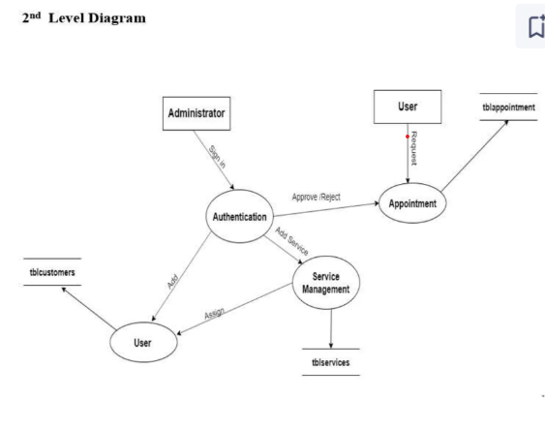

5. Planning of the Project work
The project will be developed using an iterative approach, starting with the core functionalities of appointment booking and staff management. The development process will involve requirements gathering, design, implementation, testing, and deployment. Agile methodologies will be employed to ensure flexibility and adaptability throughout the project lifecycle. (Include Gantt Chart here with milestones like Requirements Gathering, UI Design, Database Design, Backend Development, Testing, Deployment)

Include a Gantt chart for timeline with milestones.

Features
- User Interface Features: Intuitive navigation, responsive design for different devices, clear display of appointment availability.
- Functional Features: Online appointment booking, client profile management, staff scheduling, service management, reporting.
- Security Features: Secure user authentication, data encryption, access control.
- Performance Features: Fast loading times, efficient database queries, scalability.
- Reporting and Analytics: Generate reports on appointments, revenue, staff performance.
- User Experience Enhancements: Email/SMS notifications for appointment reminders, booking confirmations.

System architecture
Provide an overview of the system architecture. How will different components interact with each other? You can provide a high level diagram to understand the system.

User Interface (UI)
Describe the user interface design. You can include Form designs, wireframes or mockups if applicable.

Technology Stack
List the technologies, programming languages, frameworks, and databases you'll use.

Testing Plan
The system will undergo rigorous testing to ensure functionality and reliability. Unit tests will be conducted to verify individual components. Integration tests will check the interaction between different modules. User acceptance testing (UAT) will be performed by potential users to validate the system's usability. Test cases will include scenarios like booking appointments, canceling appointments, managing staff schedules, and generating reports.

Provide test cases.
Here are some test cases for the Salon Appointment System, categorized for clarity:
I. Appointment Booking:
- Valid Booking:
  - Input: Select a service, staff member, date, and time. Provide valid client information.
  - Expected Result: Appointment booked successfully. Confirmation message displayed. Appointment appears in the salon's schedule and the client's booking history.
- Invalid Booking (Date/Time):
  - Input: Select a date in the past.
  - Expected Result: Error message displayed: "Cannot book appointments in the past."
  - Input: Select a time slot that is already booked.
  - Expected Result: Error message displayed: "Selected time slot is not available."
- Invalid Booking (Client Information):
  - Input: Provide incomplete or invalid client information (e.g., missing phone number, invalid email format).
  - Expected Result: Error message displayed: "Please provide valid client information."
- Booking with Special Requests:
  - Input: Include special requests in the booking (e.g., specific product, allergies).
  - Expected Result: Special requests are recorded and visible to the salon staff.
- Booking with Different Service Durations:
  - Input: Book services with varying durations.
  - Expected Result: Appointment schedule accurately reflects the duration of each service.
- Back-to-Back Bookings:
  - Input: Book appointments consecutively with different clients and services.
  - Expected Result: System correctly manages back-to-back bookings without conflicts.
- Booking Across Staff Shifts:
  - Input: Attempt to book an appointment that spans across two staff shifts.
  - Expected Result: System handles shift changes correctly.
II. Client Management:
- Creating a New Client Profile:
  - Input: Enter valid client information.
  - Expected Result: Client profile created successfully.
- Editing Client Profile:
  - Input: Modify existing client information.
  - Expected Result: Client profile updated successfully.
- Searching for a Client:
  - Input: Search for a client by name, phone number, or email.
  - Expected Result: Relevant client profiles are displayed.
- Viewing Client History:
  - Input: Access a client's appointment history.
  - Expected Result: Client's past and upcoming appointments are displayed.
III. Staff Scheduling:
- Creating Staff Schedule:
  - Input: Define staff working hours and days.
  - Expected Result: Staff schedule created successfully.
- Editing Staff Schedule:
  - Input: Modify existing staff schedule.
  - Expected Result: Staff schedule updated successfully.
- Viewing Staff Availability:
  - Input: View staff availability for a specific date.
  - Expected Result: Staff availability displayed correctly.
- Managing Staff Leave/Vacation:
  - Input: Record staff leave or vacation.
  - Expected Result: Staff unavailability reflected in the appointment schedule.
IV. Reporting:
- Generating Appointment Reports:
  - Input: Select date range for the report.
  - Expected Result: Appointment report generated successfully, showing details like client name, service, staff, and time.
- Generating Revenue Reports:
  - Input: Select date range for the report.
  - Expected Result: Revenue report generated, showing total revenue, revenue per service, etc.
- Generating Staff Performance Reports:
  - Input: Select date range and staff member.
  - Expected Result: Report shows the number of appointments handled by the staff member, revenue generated, etc.
V. Security:
- Login/Authentication:
  - Input: Enter valid username and password.
  - Expected Result: Successful login.
  - Input: Enter invalid username or password.
  - Expected Result: Error message displayed: "Invalid username or password."
- Authorization:
  - Input: Attempt to access admin functionalities with a regular user account.
  - Expected Result: Access denied.
- Data Security:
  - Input: Attempt to inject SQL code into input fields.
  - Expected Result: System should prevent SQL injection attacks.
VI. Performance:
- System Load:
  - Input: Simulate multiple users accessing the system simultaneously.
  - Expected Result: System should handle the load without performance degradation.
- Response Time:
  - Input: Perform various actions (e.g., booking, searching).
  - Expected Result: System should respond within an acceptable time frame.
VII. User Interface (UI):
- Responsiveness:
  - Input: Access the system on different devices (desktop, tablet, mobile).
  - Expected Result: UI should adapt to different screen sizes.
- Usability:
  - Input: Perform various tasks using the system.
  - Expected Result: System should be easy to navigate and use.

Expected Outcome
The successful completion of this project will result in a functional and user-friendly salon appointment system. This system will enable salons to manage appointments efficiently, reduce administrative overhead, improve customer satisfaction, and increase revenue. Clients will benefit from the convenience of online booking and appointment management. The project will also provide valuable experience in software development and project management.

Resources and Limitations
Resources required for this project include a development environment (computer, software), internet access, and time. The project's limitations include the scope defined, which may not cover all possible salon management features. The project's success is also dependent on the chosen technologies and the development team's expertise.

Conclusion (100-150 words)
The Salon Appointment System project offers a practical solution to the challenges faced by salons in managing appointments. By leveraging web technologies, this project aims to create a system that is efficient, user-friendly, and scalable. The successful implementation of this system will significantly benefit salons and their clients by streamlining the appointment process and enhancing the overall experience.

References
Please mentioned naman

